[(4) Scheduling | FIFO, Priority, Weighted Fair Queuing | Improve QoS | Computer Networks | Part 2 - YouTube](https://www.youtube.com/watch?v=MvsOZXRw7O0)

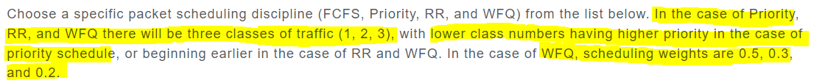

FIFO (First in first out)

The packets get sent out as the come in.

The way it works is that the packet types take turns based on their priority. I can have 3 packets, 2 of them are of packet type 3 and one is of type 1. 1 will go first then the first one of the packet 3 type goes next. Let’s say on the next time slot a packet of type 2 comes in, that one will go next, then lastly the packet of type 3 that arrived last in the last slot will go.

Look at notes

Very similar to RR, but we care about weights? not sure.

look at notes on paper to understand further.



look at notes

